QUANTUM SCATTERING REPORT

Shufan ZHANG
999018435

0. Model
The numerical calculations use the lecture convention m=1 and ħ=1. For the free Gaussian,
ψ(0,x) = (2α/π)¹⁄⁴ exp[-α(x-x₀)²] exp[ip₀(x-x₀)]
The interacting calculations use
V(x) = (0.5x² - 0.8) exp(-0.1x²).
This is a symmetric central well surrounded by two barriers.

1. Part 1 - Free Gaussian wavepacket

1.1 Initial Gaussian: changing α
At fixed mean momentum p₀=1, increasing α decreases the width of the wavepacket in real space, since Δx=1/(2√α). Therefore, the Gaussian becomes narrower as α increases.
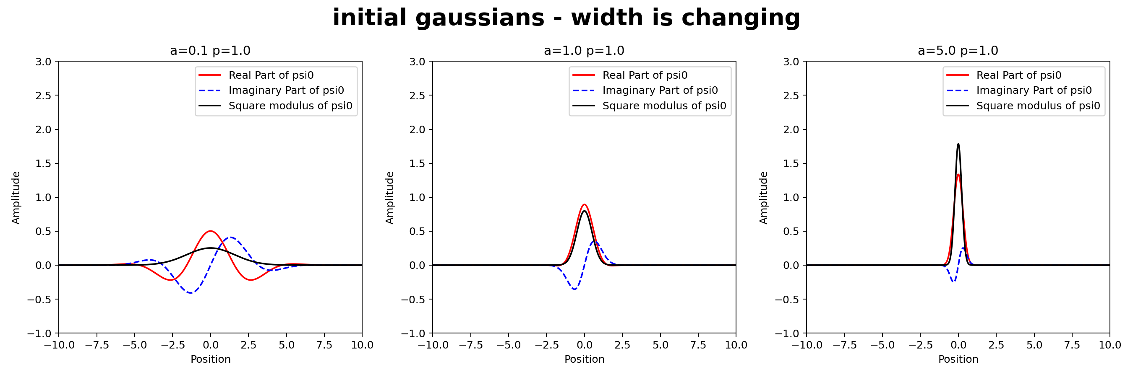
Figure 1. Initial Gaussian states for α=0.1, 1, and 5 at fixed p₀=1. The black curve is |ψ|²; red/blue curves are the real/imaginary parts.

1.2 Initial Gaussian: changing mean momentum p₀
At fixed α=1, as p0 increases, the wavefunction oscillates more rapidly, while the probability density |ψ|² remains unchanged.
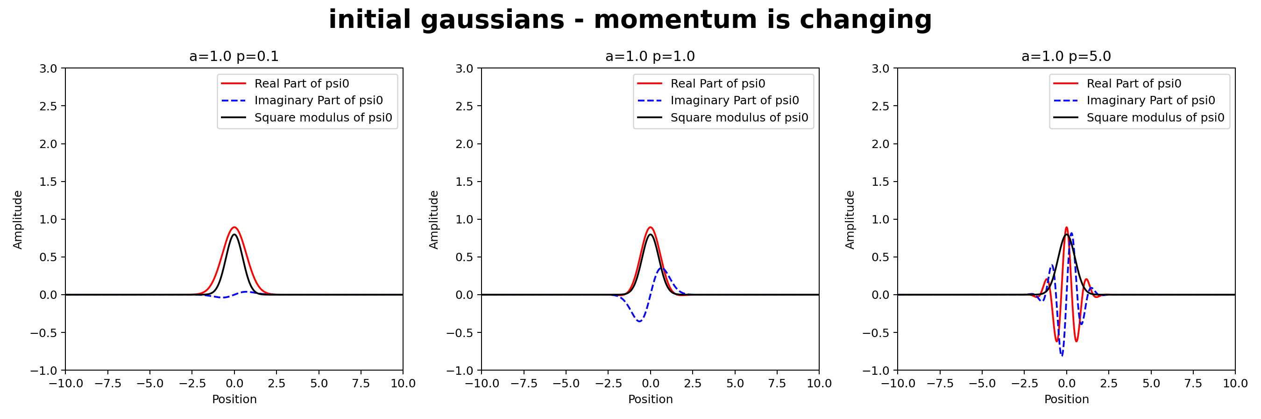
Figure 2. Initial Gaussian states for p₀=0.1, 1, and 5 at fixed α=1. The phase oscillates more rapidly as p₀ increases.

1.3 Free propagation and spreading (t>0)
As time increases, the center of the free Gaussian wavepacket moves to the right with velocity p0​/m. At the same time, the wavepacket spreads in real space, so its spatial width increases continuously during propagation.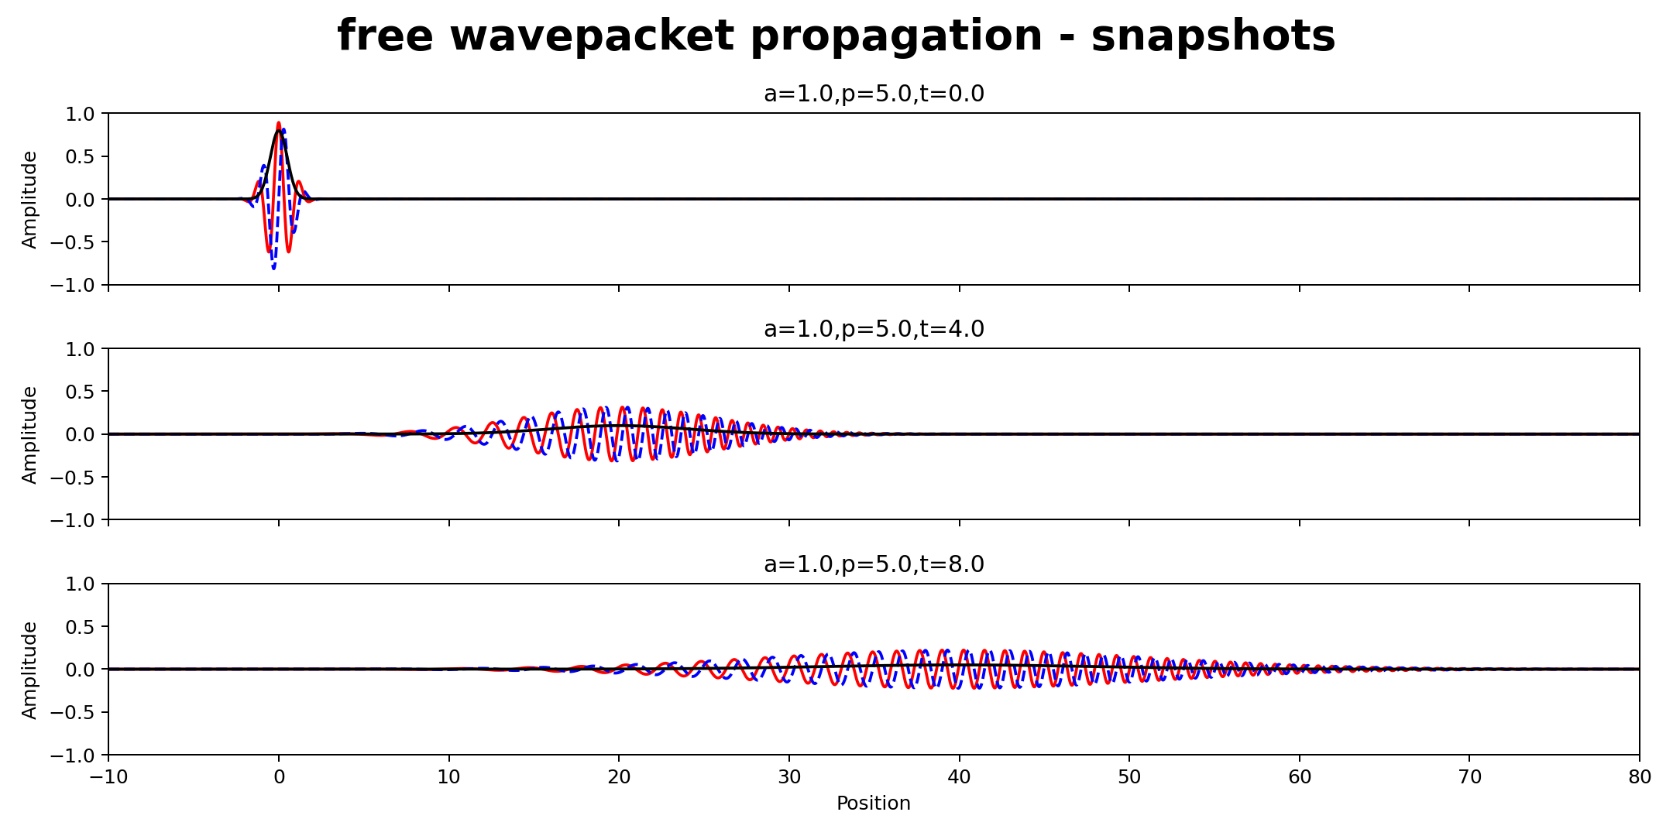
Figure 3. Free propagation snapshots for α=1, p₀=5. The wavepacket moves to the right at the expected group velocity and broadens with time.

2. Part 2 - Regularized Dirac delta function
The regularization used in the project is
δ_L(p) = sin(pL)/(πp), δ_L(0)=L/π.
As L increases, the central peak becomes taller and narrower. Although δ_L(p) does not converge pointwise, it approaches the Dirac delta distribution in the sense that ∫φ(p)δ_L(p) dp→φ(0).

2.1 Numerical distribution test
The test function is the momentum-space Gaussian φ(p) with α=1 and p₀=5. The numerical integration window is fixed at p∈[-10,10] for every L.
L | ∫φ(p)δ_L(p) dp | φ(0) | Absolute difference
10 | 0.0012166507 | 0.0012193111 | 2.660e-06
100 | 0.0012190874 | 0.0012193111 | 2.237e-07
1000 | 0.0012193480 | 0.0012193111 | 3.696e-08
The error decreases from 2.66×10⁻⁶ at L=10 to 3.70×10⁻⁸ at L=1000. The convergence toward φ(0)=0.0012193111 is a direct numerical verification of the defining action of the Dirac delta distribution.

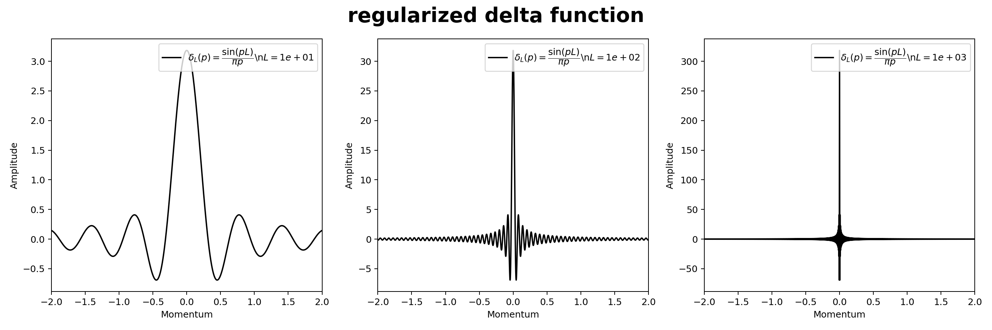 Figure 4. The regularized delta function for L=10, 100, and 1000. Increasing L concentrates the distribution more strongly around p=0.

3. Part 3 - Stationary scattering and resonances

3.1 Numerical method
For each E>0, let k=√(2E) under m=ħ=1. The physical stationary state for a particle incident from the left has the asymptotic form
ψ_{E}(x→−∞) = exp(ikx) + R(E) exp(−ikx)
ψ_{E}(x→+∞) = T(E) exp(ikx)
For the finite-difference calculation, a modified state with unit transmitted amplitude is used instead:
ψ̄_{E}(x→−∞) = A(E) exp(ikx) + B(E) exp(−ikx)
ψ̄_{E}(x→+∞) = exp(ikx)
ψ_{E}(x) = ψ̄_{E}(x)/A(E), T(E)=1/A(E), R(E)=B(E)/A(E).
The physical transmission and reflection probabilities are |T|² and |R|², with |T|²+|R|²=1 as the numerical consistency check.

3.2 Transmission spectrum
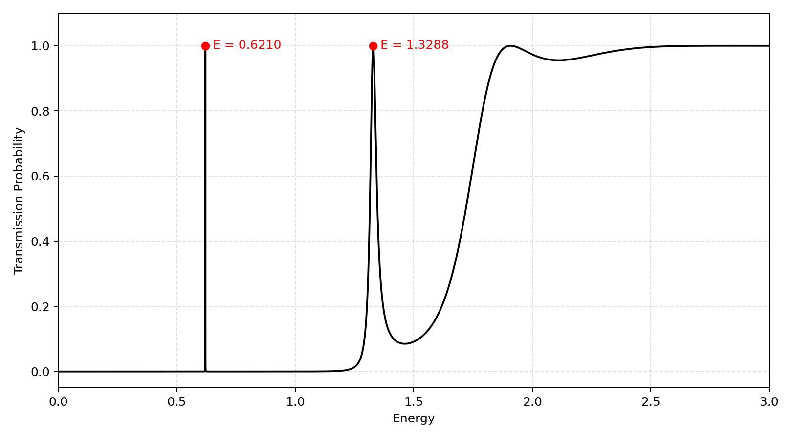
Figure 5. Calculated transmission probability over 0<E<3. Two sharp below-barrier resonances are visible at E≈0.6210 and E≈1.3288; at higher energy the transmission tends toward unity.
The transmission spectrum shows two narrow resonance peaks at E≈0.6210 and E≈1.3288, where the transmission probability reaches almost one. At higher energies, the transmission gradually approaches one.
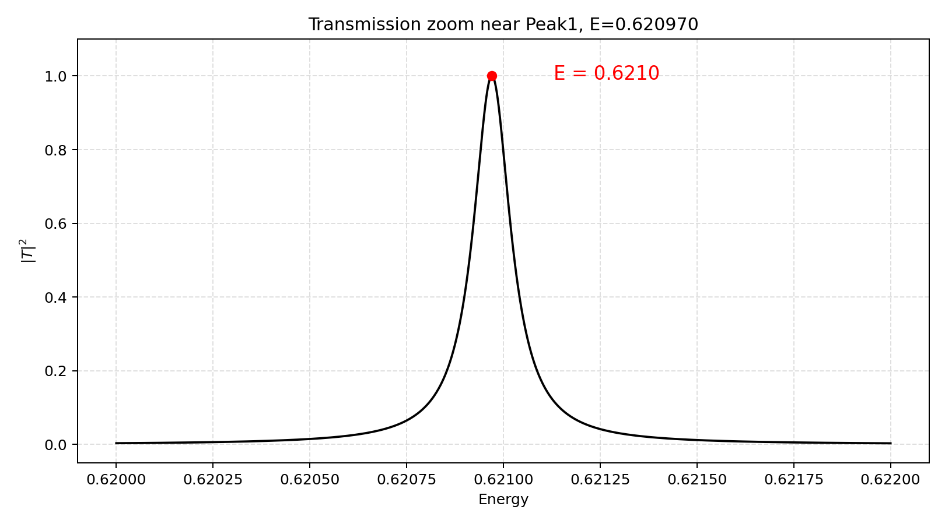 | 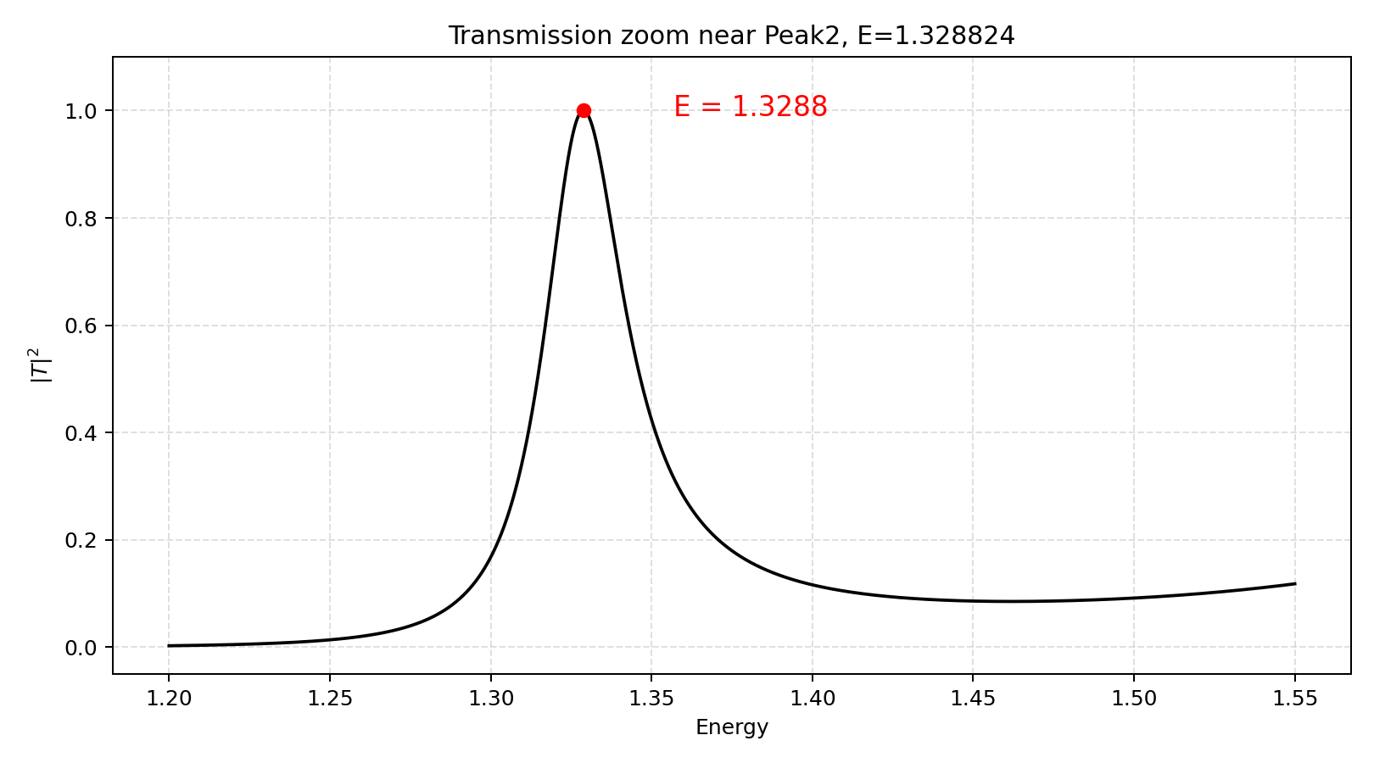
Figure 6a. Zoom of the first peak at E≈0.6210 | Figure 6b. Zoom of the second peak E≈1.3288

3.3 Continuum wavefunctions around the resonances
The following panels show the modified state ψ̄ defined in Section 3.1.
First resonance. At E=0.40 and E=0.75, the physical transmission is almost zero and the wave is almost completely reflected. At the resonance energy E≈0.62097, |T|²≈1 and the wave is almost perfectly transmitted through the potential, and a large oscillation is also formed inside the central well.
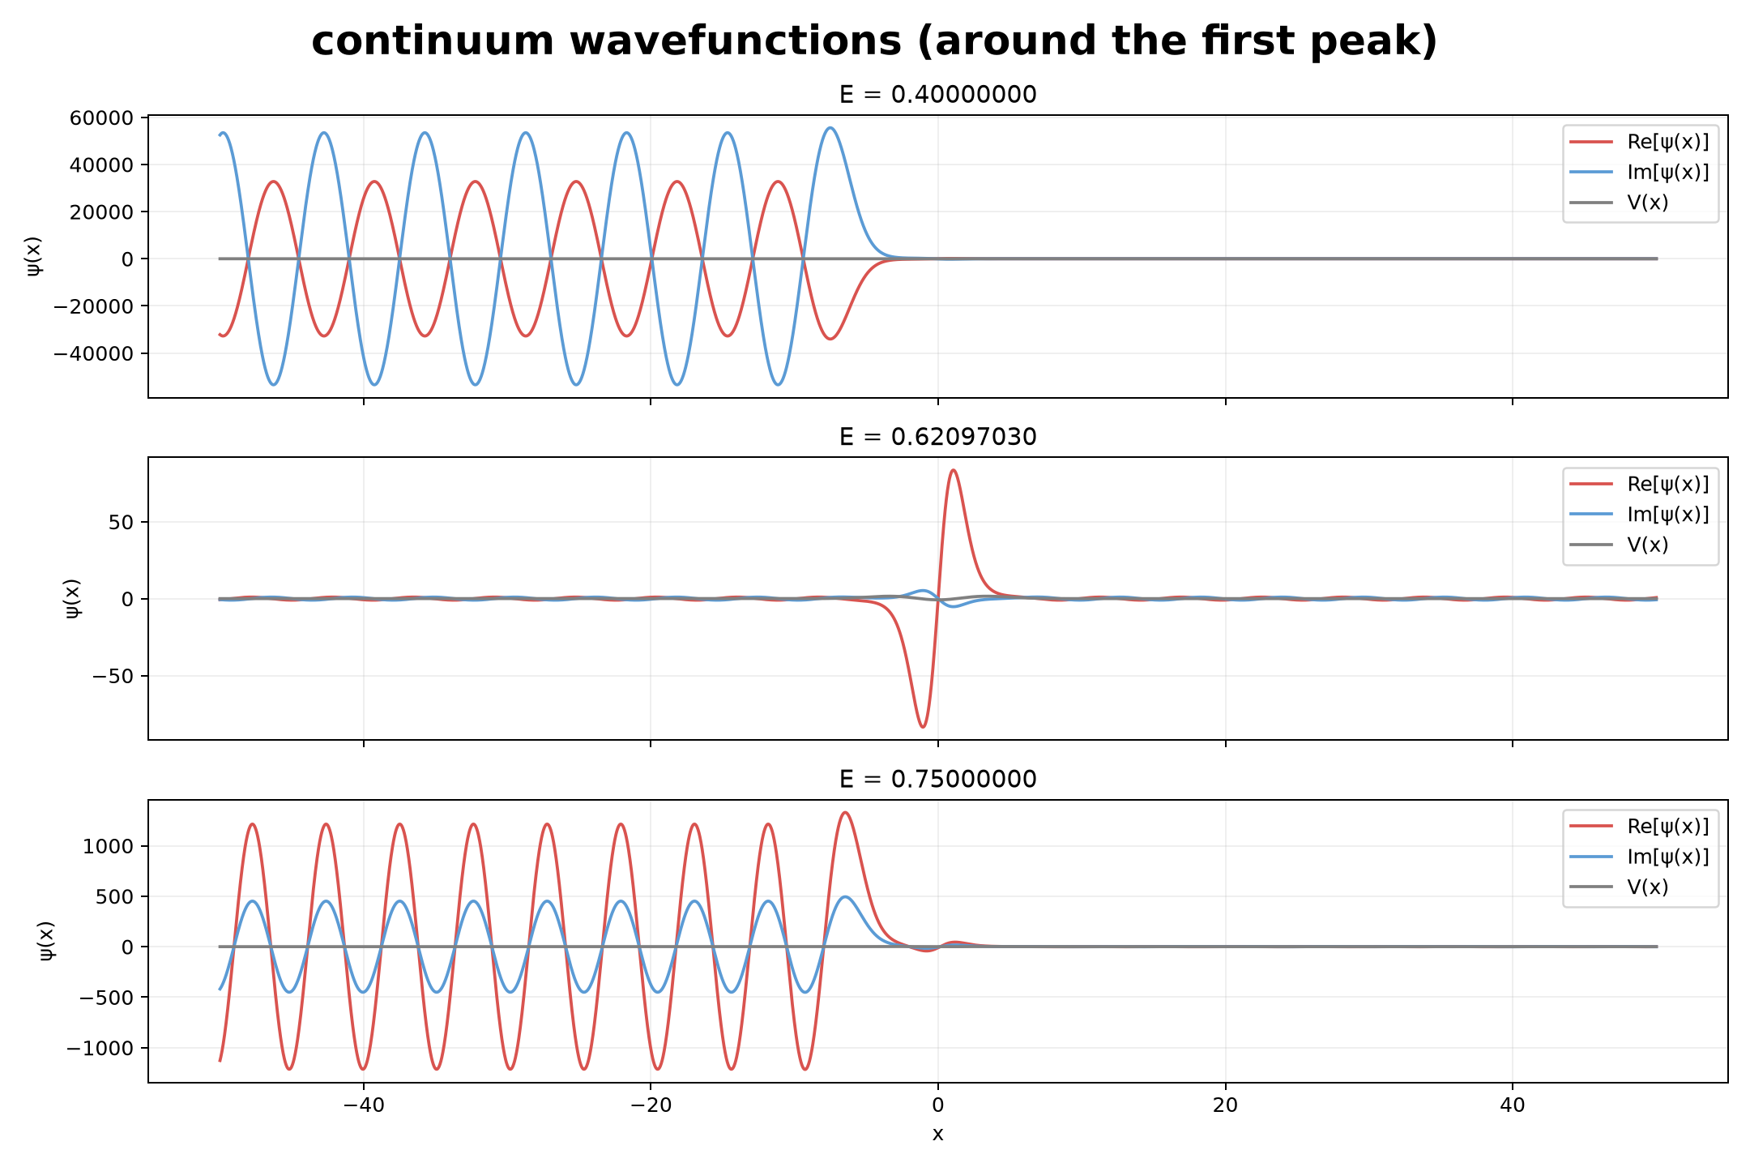
Figure 7. Modified continuum wavefunctions around the first resonance.
Second resonance. The same behavior appears around E≈1.32882. Away from the peak (E=1.00 and E=1.60), the transmission is much smaller, whereas at the resonance |T|²≈1 and the wave is almost perfectly transmitted through the potential, and a large oscillation is also formed inside the central well.
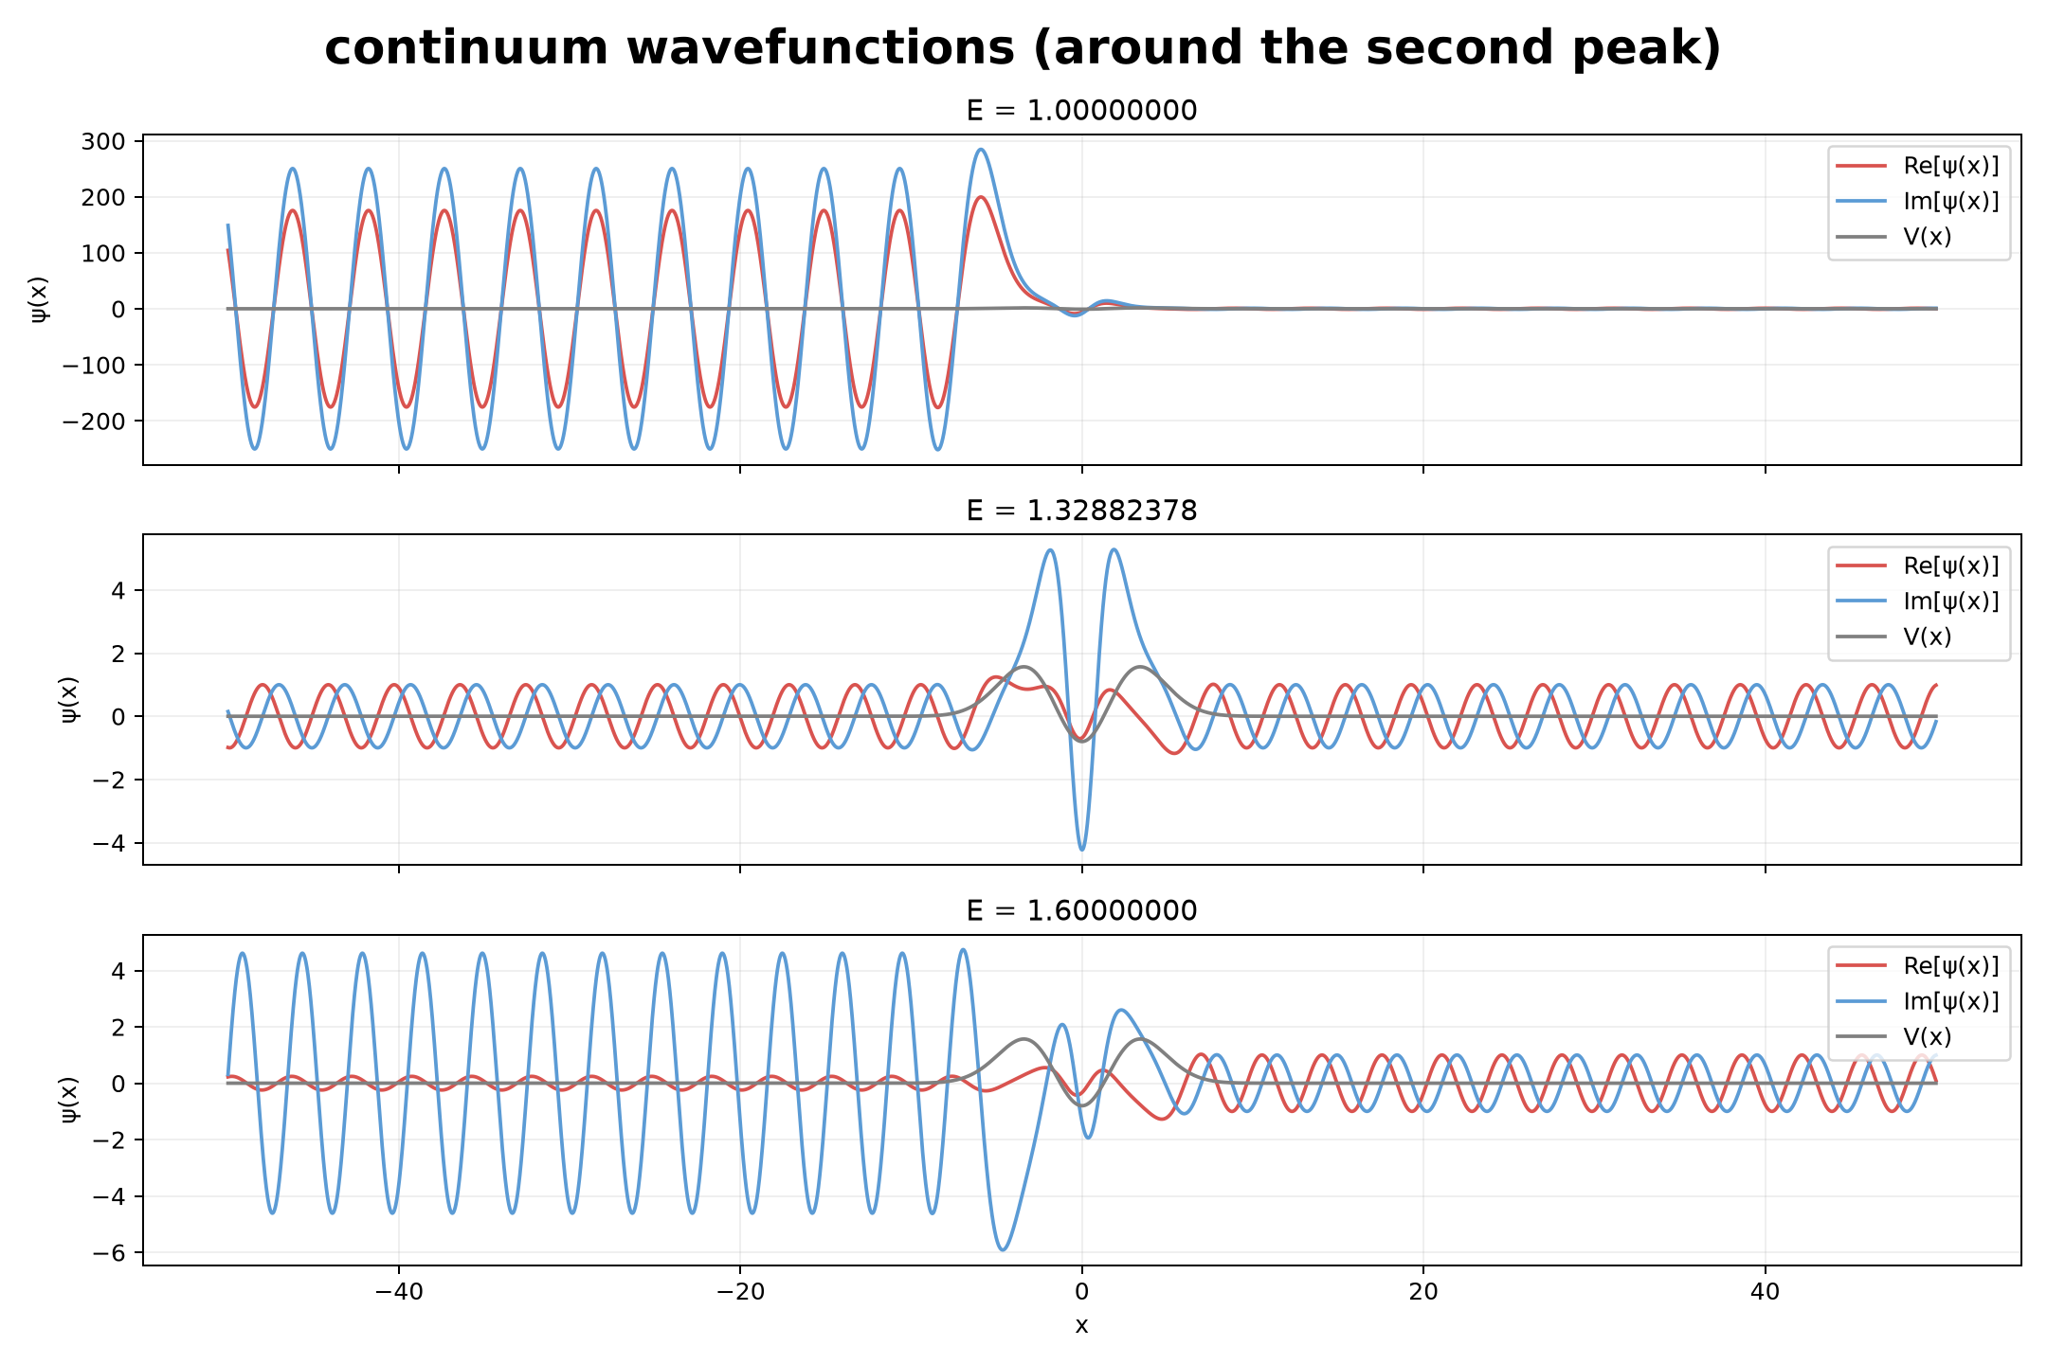
Figure 8. Modified continuum wavefunctions around the second resonance.

4. Part 4 - Wavepacket scattering
In Part 4, a Gaussian wavepacket is used as the incident wavepacket. It is constructed by superposing the left-incident stationary scattering states obtained in Part 3 with a Gaussian momentum distribution:
Ψ(t,x)=∫dpϕ(p)ψp​(x)e−iE(p)t , E=p²/2.

4.1 Blocked packet
The blocked packet is centered at E₀=1.0, well below the barrier top and away from either resonant peak. Across the relevant momentum distribution the transmission is extremely small. Therefore, almost the entire wavepacket is reflected back to the left. The snapshots show exactly this: the packet approaches the barrier, overlaps the potential well region, and then comes back as a reflected packet with negligible transmitted weight.
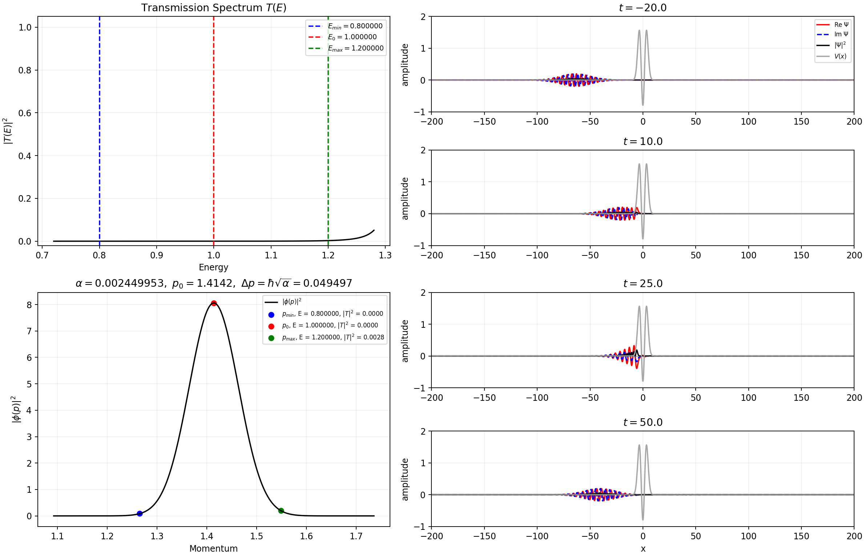
Figure 9. Blocked scenario. Left: stationary transmission spectrum and incident momentum density. Right: time snapshots showing almost complete reflection.

4.2 Partially blocked packet
The reference center E₀=1.328814 lies essentially on the second resonance peak, but the packet has a much larger finite momentum width Δp=0.015556. Consequently only part of the incident spectrum sits in the high-transmission resonance region; neighboring components have much smaller |T|². Therefore, only the momentum components whose energies lie within the second resonance peak can be transmitted efficiently. Components whose energies deviate too far from the resonance have much smaller transmission probabilities and are reflected back to the left.
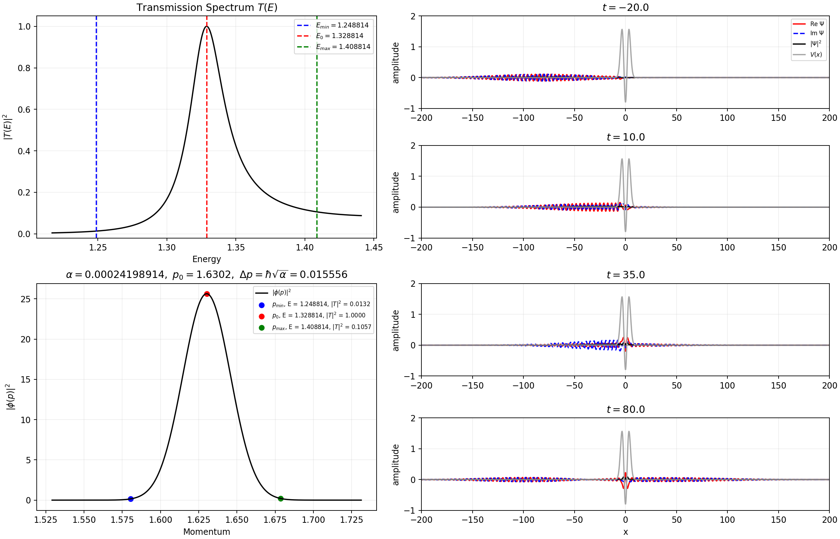
Figure 10. Partially blocked scenario centered near the second resonance. The finite spectral width covers both resonant and non-resonant energies, producing simultaneous transmission and reflection.

4.3 Passing packet
For E₀=2.7, the transmission probability is close to one over almost the whole momentum distribution. Therefore, almost all components of the wavepacket pass through the potential region and continue propagating to the right, with only a very small reflected part.
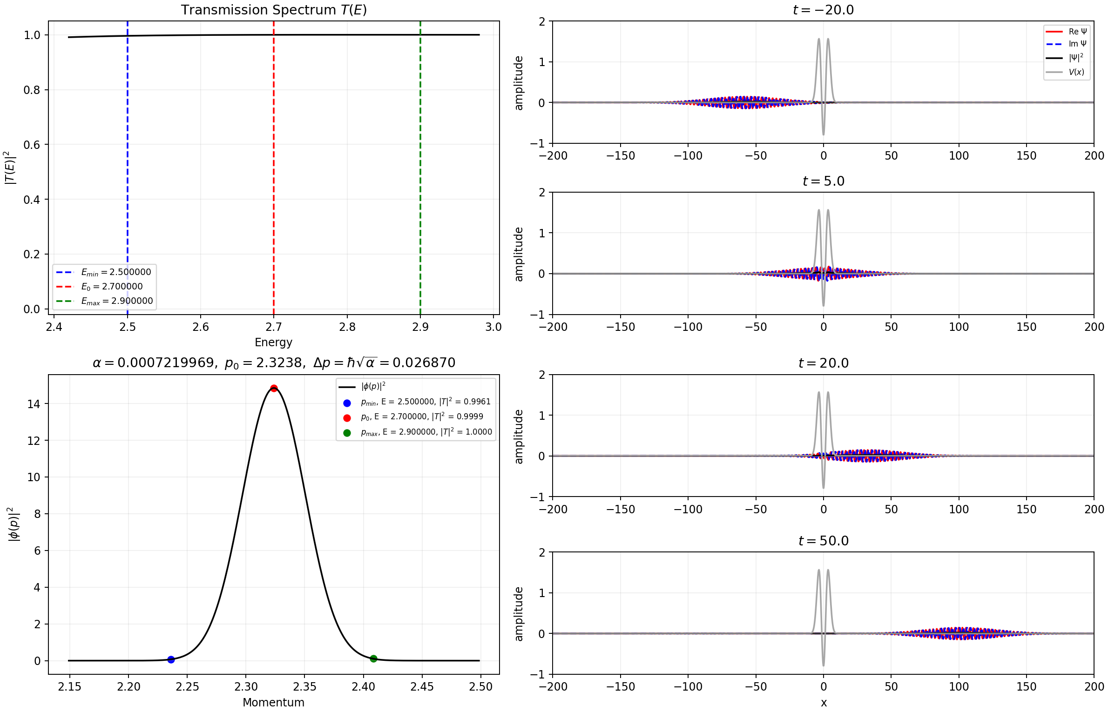
Figure 11. Passing scenario at high energy. Nearly the entire wavepacket crosses the potential.

4.4 Narrow range at second resonance peak
This case uses a very narrow momentum range centered on the second resonance peak. Since almost the entire range lies within the high-transmission region, the transmission probability is close to one for nearly all components of the wavepacket. Therefore, most of the wavepacket passes through the potential.
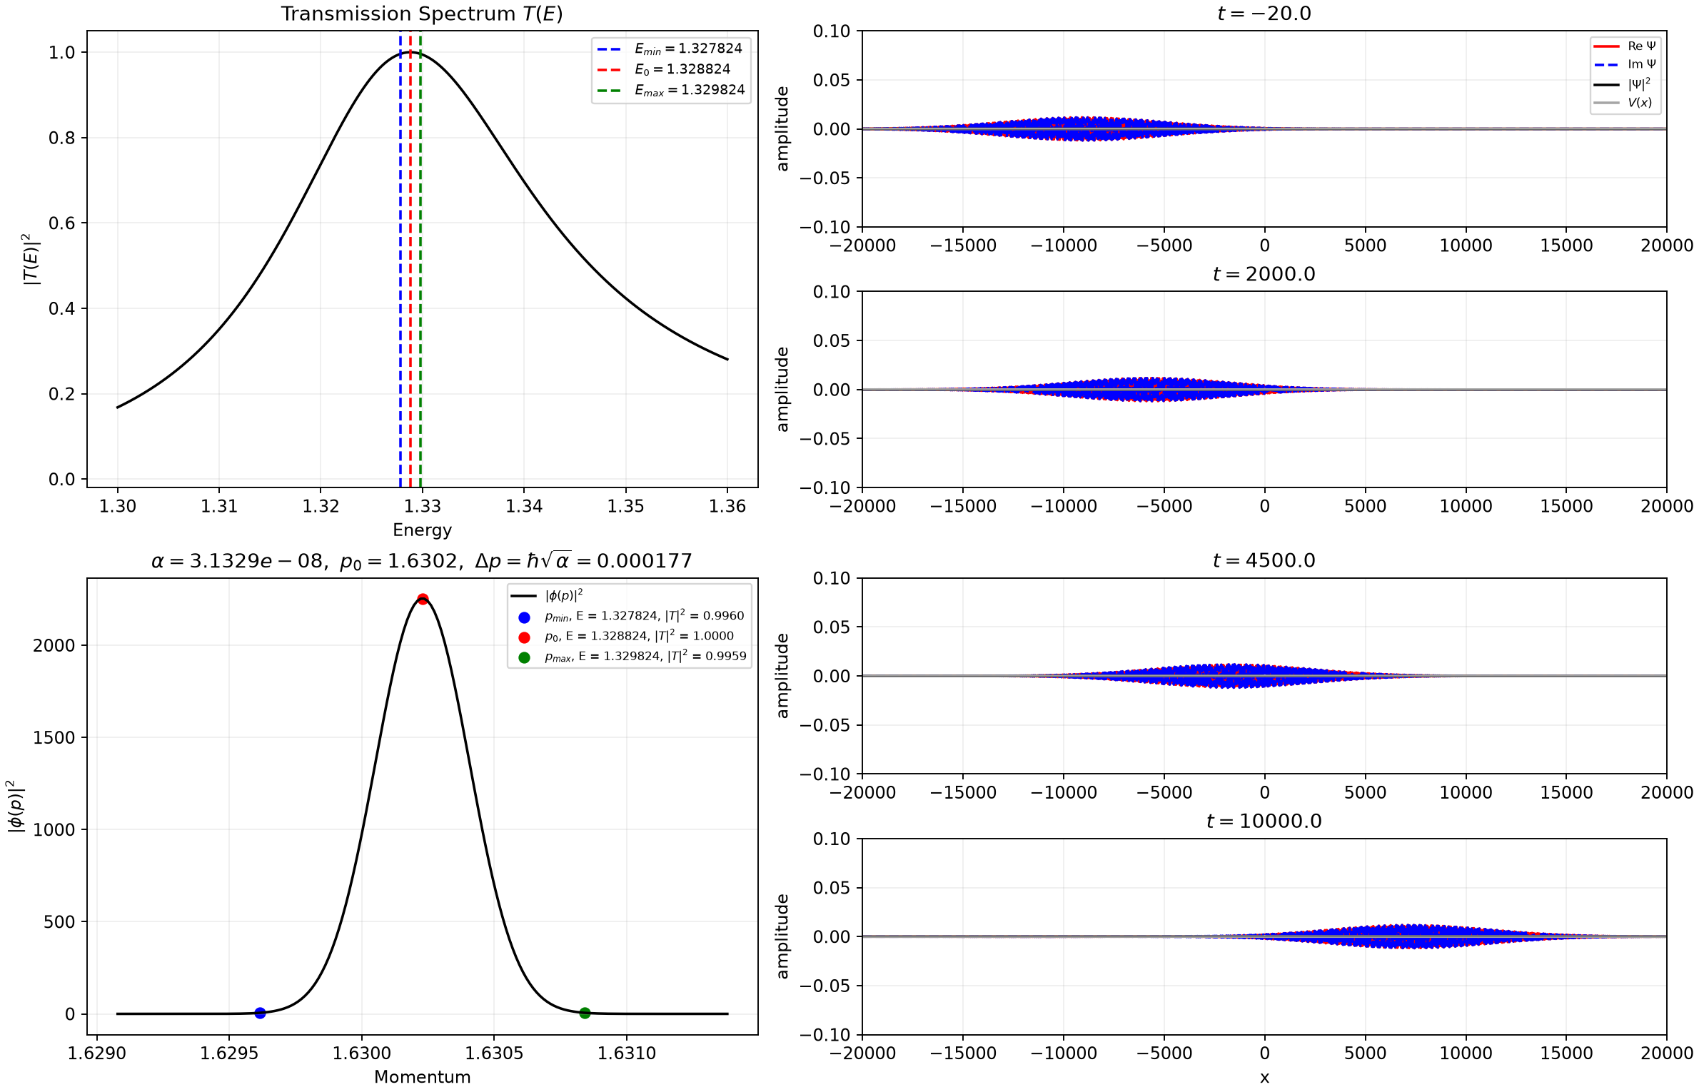
Figure 12. Extremely narrow-band packet centered exactly at the numerically determined second resonance. Its large spatial width is the Fourier counterpart of the tiny momentum width.

